Dear Middle School Students,
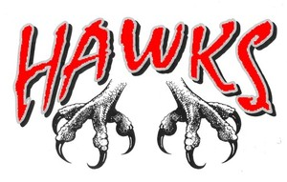
Join us for ……
HAMS NIGHT!!!
with the HAHS Marching Band
Friday, October 4, 2019
- Perform with us ON THE FIELD at a varsity football game!
- Meet in the HS Band Room at 5:15pm
- Get a FREE snack from the Music Association concession stand!
- See your band teacher for music during your lesson!
- RSVP to Mrs. Freeman or Mrs. Kline by Sept. 26th
Can’t wait to see you there!
Mrs. Kline --- MegKli@hasdhawks.org

