Hamburg Area High School Marching Band
ALUMNI NIGHT!

The Hamburg Area High School Marching Band would like to invite all Hamburg Band Alumni, Faculty, and Staff to join us for Alumni Night. We welcome you to bring your instrument and play with us in the stands! (We have lots of cowbells, even if you’d like to join us just for fun!)
- Friday, October 25, 2019 @ 7:00pm (Homecoming/Sr. Night)
* For a brief warm-up, please meet in the Band Room @ 5:30pm. We will play on the field during PREGAME
- Free admission & free HAMA food/drink for all participants.
- RSVP by Friday, October 18th
- Please call or email for any additional information
  - MegKli@hasdhawks.org or 610-562-2241 Ext. 2147
- Join our FB group: Hamburg Area HS Bands
We look forward to seeing you there!
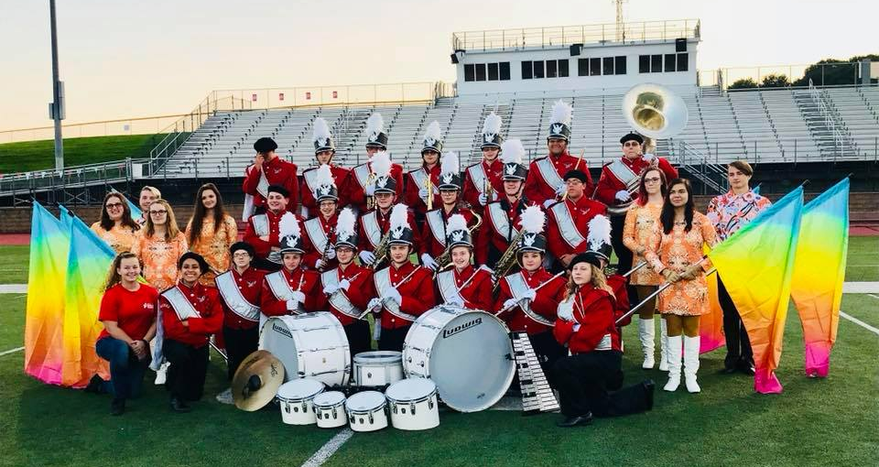
Mrs. Megan Kline, Director; Mrs. Carri Sola, Color Guard Instructor;
and the HASD Marching Band!

