7th & 8th Grade JANUARY 2019-2020
MONDAY | TUESDAY | WEDNESDAY | THURSDAY |  | FRIDAY
REMINDERS:  - HIGH NOTE Payment #2 – Due Friday, January 24  - HIGH NOTE Payment #3 – Due Friday, March 6 |  | 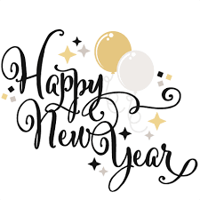  1 | 2 |  | 3 – Day 4  Pd 1 – Clarinet 1  AM Flex – (Make Up)  Pd 2 – Clarinet 2  Pd 3 – Alto Sax 1/Horn  Pd 4 – Alto Sax 2  Pd 5 – Alto Sax 3 -  Pd 6 – Flute 1/Oboe  PM Flex – Flute 2
6 | 7 – Day 6  Pd 1 – Trumpet 1  AM Flex – (Make Up)  Pd 2 – Trumpet 2  Pd 3 – Trombone  Pd 4 – Perc 1  Pd 5 – Perc 2  Pd 6 – Mallet Perc  PM Flex – 7&8 BAND!! | 8 | 9 – Day 2 (LVC BANDFEST)***  Pd 1 – Mallets  AM Flex = 7&8 BAND!  Pd 2 – Flute/Clarinet  Pd 3 – Saxes/Horn/Trumpet  Pd 4 – BCl/Bari/Trombone  Pd 5 – Perc 1  Pd 6 – Perc 2  PM Flex – N. Donne |  | 10
13 – Day 4  Pd 1 – Flute 2  AM Flex – (Make Up)  Pd 2 – Clarinet 1  Pd 3 – Clarinet 2  Pd 4 – Alto Sax 1/Horn  Pd 5 – Alto Sax 2  Pd 6 – Alto Sax 3  PM Flex – Flute 1/Oboe | 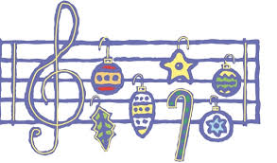  14 | 15 – Day 6  Pd 1 – Mallet Perc  AM Flex – (Make Up)  Pd 2 – Trumpet 1  Pd 3 – Trumpet 2  Pd 4 – Trombone  Pd 5 – Perc 1  Pd 6 – Perc 2  PM Flex – 7&8 BAND!! | 16 |  | 17 – Day 2 (Early Dismissal)  Pd 1 – Perc 2  AM Flex = 7&8 BAND??????  Pd 2 – Mallets  Pd 3 – Flute/Clarinet  Pd 4 – Saxes/Horn/Trumpet  Pd 5 – BCl/Bari/Trombone  Pd 6 – Perc 1  PM Flex – N. Donne
20  No School  Teacher In-Service | 21 | 22 – Day 4  Pd 1 – Flute 1/Oboe  AM Flex – (Make Up)  Pd 2 – Flute 2  Pd 3 – Clarinet 1  Pd 4 – Clarinet 2  Pd 5 – Alto Sax 1/Horn  Pd 6 – Alto Sax 2  PM Flex – Alto Sax 3 | 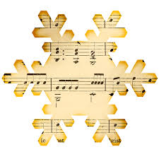  23 |  | 24 – Day 6  Pd 1 – Perc 2  AM Flex – (Make Up)  Pd 2 – Mallet Perc  Pd 3 – Trumpet 1  Pd 4 – Trumpet 2  Pd 5 – Trombone  Pd 6 – Perc 1  PM Flex – 7&8 BAND!!  ** HIGH NOTE PMT #2 / FULL PAYMENT DUE TODAY
27 | 28 – Day 2  Pd 1 – Perc 1  AM Flex = 7&8 BAND!  Pd 2 – Perc 2  Pd 3 – Mallets  Pd 4 – Flute/Clarinet  Pd 5 – Saxes/Horn/Trumpet  Pd 6 – BCl/Bari/Trombone  PM Flex – N. Donne | 29 |  | 30 – Day 4  Pd 1 – Alto Sax 3  AM Flex – (Make Up)  Pd 2 – Flute 1/oboe  Pd 3 – Flute 2  Pd 4 – Clarinet 1  Pd 5 – Clarinet 2  Pd 6 – Alto Sax 1/Horn  PM Flex – Alto Sax 2 |  | 31

